Project Structure:

Project_gabriel
Src-→ Under
>Gabriel_package
>Common_Method.java
> DataDrivenTestdemo.java
> Gabriel_Signup.java
Data folder
Gabriel_signup.xlsx

Input Data File:

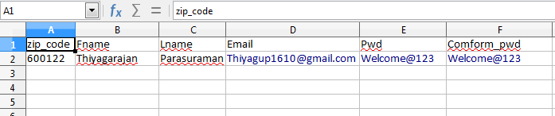
Common_methods class:

package Gabriel_Project;

import java.io.IOException;
import java.util.NoSuchElementException;
import java.util.concurrent.TimeUnit;
import org.apache.commons.compress.archivers.dump.InvalidFormatException;
import org.openqa.selenium.By;
import org.openqa.selenium.WebDriver;
import org.openqa.selenium.WebElement;
import org.openqa.selenium.chrome.ChromeDriver;
import org.openqa.selenium.interactions.Actions;
import org.testng.annotations.DataProvider;

public class Common_Method {

WebDriver driver;
static Actions ref;
private TimeUnit TimeUnits;
String excelFileName;

public void startApp_Browser(String browser, String url) {

if(browser.equalsIgnoreCase("chrome")) {
System.setProperty("webdriver.chrome.driver", ".//drivers/chromedriver.exe");
driver =new ChromeDriver();
driver.manage().window().maximize();
System.out.println(driver.findElements(By.tagName("a")).size());
}
driver.navigate().to(url);
driver.manage().window().maximize();
driver.manage().timeouts().implicitlyWait(10, TimeUnit.SECONDS);
}

public WebElement locateElement(String type, String value)
{
try
{
switch(type.toLowerCase())
{
case"id":return driver.findElement(By.id(value));
case"name":return driver.findElement(By.name(value));
case"class":return driver.findElement(By.className(value));
case"tname":return driver.findElement(By.tagName(value));
case"link":return driver.findElement(By.linkText(value));
case"plink":return driver.findElement(By.partialLinkText(value));
case"xpath":return driver.findElement(By.xpath(value));
case"css":return driver.findElement(By.cssSelector(value));
}
} catch (NoSuchElementException e) {
System.err.println("The Element with locator:"+type+" Not Found with value: "+value);
throw new RuntimeException();
}
return null;
}
public void type(WebElement ele,String value)
{
ele.clear();
ele.sendKeys(value);
}
public void click(WebElement ele)
{
ele.click();
}
public void mouseOver(WebElement ele)
{
ref = new Actions(driver);
ref.moveToElement(ele).click().build().perform();
}
public void close()
{
driver.close();
driver.quit();
}
public void webdriverwait()
{
driver.manage().timeouts().implicitlyWait(10, TimeUnits);
}
public void sleep() throws InterruptedException
{
Thread.sleep(2000);
}
@DataProvider(name="fetchData")
public String[][] getData() throws InvalidFormatException, IOException{
return DataDriverTestdemo.readExcel(excelFileName);
}

}

DataDriverTestdemo Class read the data from excel file:

package Gabriel_Project;

import java.io.IOException;

import org.apache.poi.xssf.usermodel.XSSFCell;
import org.apache.poi.xssf.usermodel.XSSFRow;
import org.apache.poi.xssf.usermodel.XSSFSheet;
import org.apache.poi.xssf.usermodel.XSSFWorkbook;

public class DataDriverTestdemo {
public static String[][] readExcel(String fileName) throws IOException
{
//this code for read the data from excel file
XSSFWorkbook workbook=new XSSFWorkbook (".//data/"+fileName+".xlsx");
XSSFSheet sheet = workbook.getSheetAt(0);
int rowCount =sheet.getLastRowNum();
System.out.println("Row count "+ rowCount);
int cellCount =sheet.getRow(0).getLastCellNum();
System.out.println("Column Count "+ cellCount);
String [][] data =new String [rowCount][cellCount];

for(int i=1;i<=rowCount;i++)
{
XSSFRow row=sheet.getRow(i);

for(int j=0;j<cellCount;j++)
{
XSSFCell cell =row.getCell(j);
data[i-1][j] = cell.getStringCellValue();
}
}
workbook.close();
return data;
}
}

Signup Page Test Cases:

package Gabriel_Project;

import org.openqa.selenium.By;
import org.openqa.selenium.WebElement;
import org.openqa.selenium.support.ui.ExpectedConditions;
import org.openqa.selenium.support.ui.WebDriverWait;
import org.testng.Assert;
import org.testng.annotations.BeforeTest;
import org.testng.annotations.Test;

public class Gabliel_Signup extends Common_Method {
@BeforeTest
public void setData() {
excelFileName = "Gabriel_signup";
}
//Data Provide get the datas from the excel sheet.
@Test(dataProvider="fetchData")
public void login(String zipcode, String FName,String LName, String Email,String pword,String cpword) throws InterruptedException
{

//lunch the browser
startApp_Browser("chrome","http://www.staging.gcnydev.com/");
//Entered the zip code
type(locateElement("id","userloc_td_zip"), zipcode);
//Click on Confirm button
click(locateElement("xpath","(//a[text()='Confirm'])[2]"));
WebDriverWait wait = new WebDriverWait(driver, 30);
wait.until(ExpectedConditions.elementToBeClickable(locateElement("xpath","// li[@class='hidden-sm-down']//*[@class='svg-user']")));
sleep();
//click on user login icon
click(locateElement("xpath","//li[@class='hidden-sm-down']//*[@class='svg- user']"));
click(locateElement("id","btnRegister"));
type(locateElement("id","userNameF"), FName);
type(locateElement("id","userNameL"), LName);
type(locateElement("id","userLoginR"), Email);
type(locateElement("id","userPassword1"), pword);
WebElement pw = locateElement("id","userPassword1");
String pws = pw.getText();
type(locateElement("id","userPassword2"), cpword);
WebElement pw1 = locateElement("id","userPassword2");
String pws1 = pw1.getText();
Assert.assertEquals(pws,pws1);
new WebDriverWait(driver, 10).until(ExpectedConditions.frameToBeAvailableAndSwitchToIt(By.xpath("// iframe[starts-with(@name, 'a-') and starts-with(@src, 'https://www.google.com/recaptcha')]")));
new WebDriverWait(driver, 20).until(ExpectedConditions.elementToBeClickable(By.xpath("//span[@id='recaptcha- anchor']"))).click();
Thread.sleep(3000);
//Here i am put the thread sleep and select the images manually and click on verify. then click on create account button
//I'm not a robot check box. it's is am not handle this type google captcha in automation.
//If you know the possiblities please kindly let me know
type(locateElement("id","btnRegister"), zipcode);

}
}

OUTPUT:Console output:

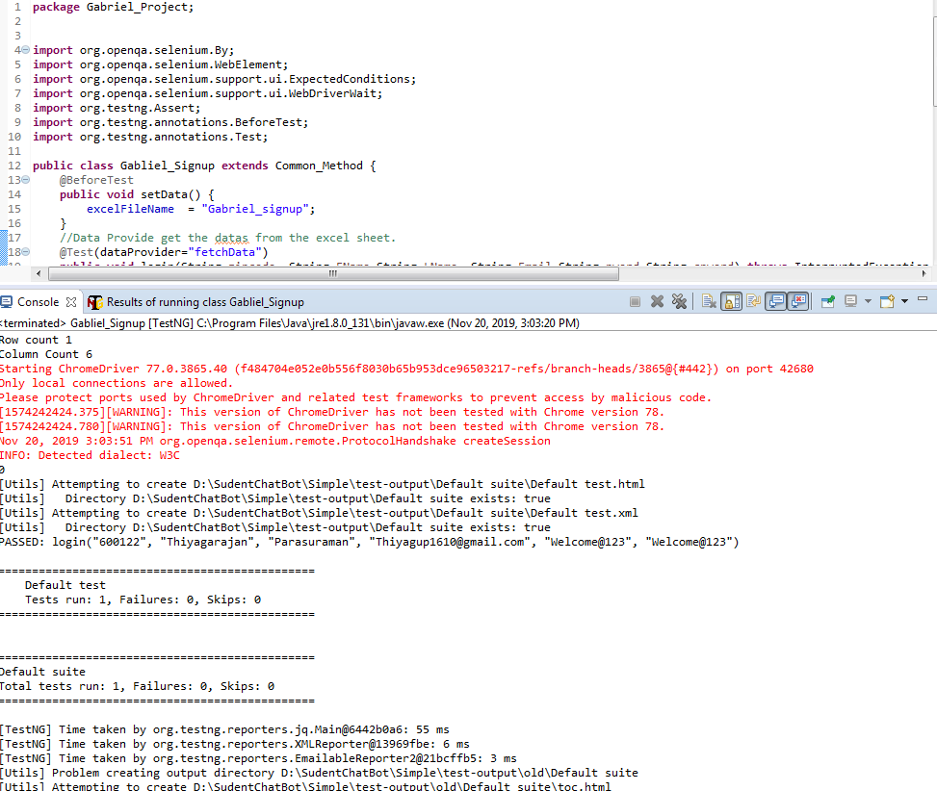

TestNG_Emailable Output:

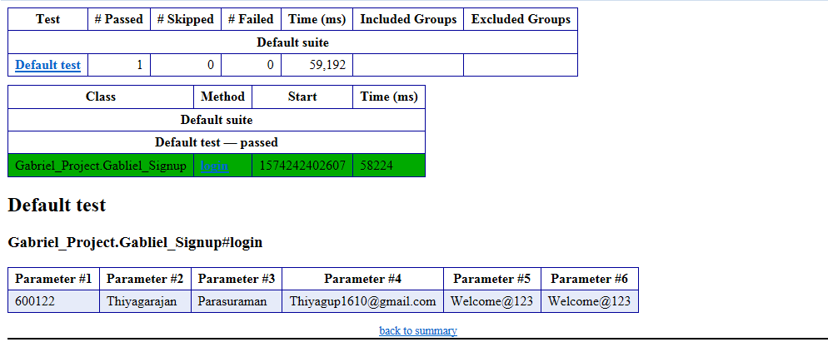

SQL Queries:

Insert comments:

Insert into table_name (Fname, Lname, Email, pword, conpword)values(“Thiyagarajan”,”Parasuraman”,”Thiyagup1610@gmail.com”,”Welcome@123”,”Welcome@123”);

Retrive values from the database:

Select * from table_name where Fname=”Thiyagarajan”

